Hi Jonathon,
I’m really excited to have Michael Leckie join the upcoming group trip to YW and wanted to share a few background notes ahead of hosting him:
https://leckiestudio.com/
Avenue Road connection: we were first introduced to him by end client, Jennifer Ouano, who selected a number of pieces for her PH unit at Vancouver House. Between Leckie and Jennifer, I belive they have spent about 900K with us. Below is the Morph stools, Pukalu table & Nonoto Comfort chairs.

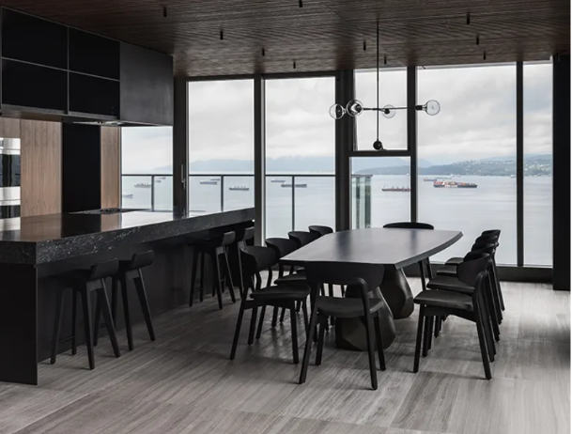
https://leckiestudio.com/portfolio/vancouver-house-penthouse-2/
Leckie also specifed/installed the Soap Tiles for Small Victory café in South Granville. I used to live in the builing above this café and was lucky to be a regular.
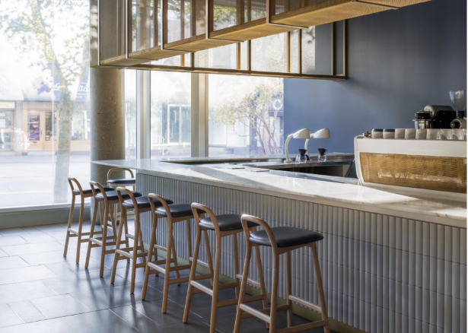

At the end of this month (October) we will be delivering over $100K of product to Leckie’s Hornby Island project. This is another private residence they’re working on for Jennifer Ouano. They have Zeitraum entry benches, custom Kuyu dining table, Abi dining chairs and Morph benches.

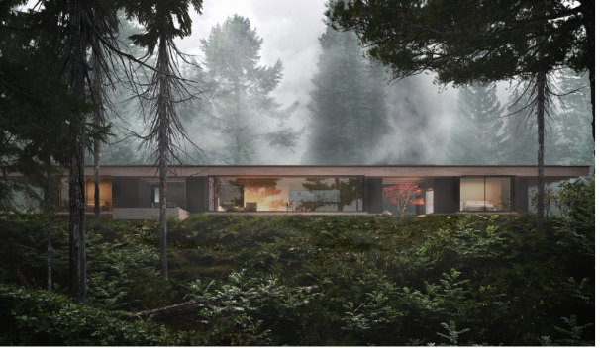
https://leckiestudio.com/portfolio/ohr/

There is also a Fogo connection.. Michael has designed prefabricated huts for rural or backcountry properties. They’ve supplied these for clients on Hornby Island, surf huts on Vancouver Island as well as Fogo which completed just last year. I know the cabin at YW is private, but if you would be open to sharing some of the inspiration and small space design elements, I think it would resonate.

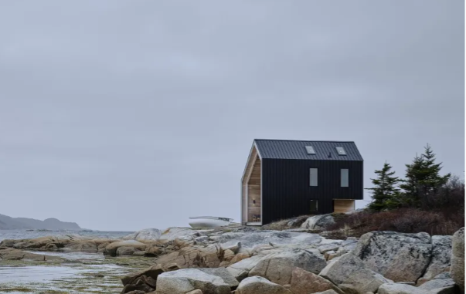
https://leckiestudio.com/portfolio/fogo-island-hut/
An interesting talking point might be the work he’s doing to renovate/rebuild the Tofino fishing pier:
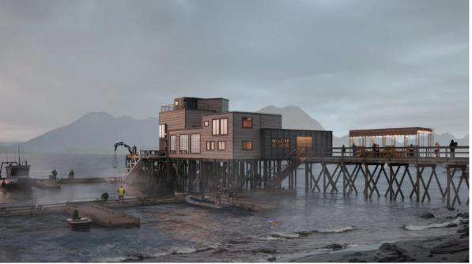
https://leckiestudio.com/portfolio/tofino-ice-house/
On the residential side, they had specified more Van Rossum, Zeitraum, Michael Verheyden, Classicon and Etel for a multi-residential project which its my understanding that the developer has it on-hold (as much of the multi-res projects in Vancouver are right now). I personally work more closely with Kate Read who lead the interiors team (Kate is amazing! We adore her.) I don’t know how engaged Michael himself is with our offering so this is a great chance for him to connect with our brands and stories. Van Rossum & Zeitraums ability to custom match the stain of their millwork has always been a draw for them. I can see Van Rossum’s newer dining and coffee table’s in their projects. Tribu is also shown well at YW and might resonate more when viewed in situ. They cover a wide range of residential and smaller commercial/hospitailty projects and I’m curious to know what he likes working on most or what type of projects they wish to do more of.. and where (local/remote/international)?
My goal for his visit is of course to deepen the relationship and inspire future collaboration. I really admire their work, enjoy working with their team and belive that there is a lot more potential we can tap into.
Looking forward to hearing how the trip goes! Please don’t hesitate to reach out if you, SW or MB have any further questions I can help answer.
Best,
Jane Doe
​Associate Director of Sales & Business Development, Vancouver

